| **SNo.** | **Project Title** | **Released Date** | **Submission Date** | **Remarks and**  **Sign of Teacher** |
| --- | --- | --- | --- | --- |
| 1. | Product Landing Page | January 24 2025 |  |  |
| 2. | Student Dashboard Page |  |  |  |
| 3. | Personal Portfolio |  |  |  |
| 4. | e-Commerce Product Page |  |  |  |
| 5 | Digital Calculator using HTML CSS and jQuery |  |  |  |
| 6 | jQuery Menus |  |  |  |
| 7 | FAQ Accordion using jQuery |  |  |  |
| 8 | jQuery Tabs |  |  |  |
| 9 | jQuery Selectable |  |  |  |
| 10 | Mini Project - Airline Reservation System using PHP, MySQL, jQuery and Bootstrap |  |  |  |

**Project - 1 Product Landing Page**

**Learning Objective:**

To understand responsive design, Bootstrap grid system and Bootstrap components

**Pre-requisites**

* Basic knowledge of HTML, CSS
* Understanding of Bootstrap framework
* Familiarity with responsive web design principles

**Resources Required**

* Bootstrap library (CSS and JS files)
* Text Editor like VSCode
* Web browser for testing

**Real-world Application of the Project**

* Enhances business’s online presence, attracting and converting potential customers.
* Demonstrates your capability to create visually appealing and user-friendly web page.

**The Product Landing Page includes the following sections:**

1. Heading - Welcoming banner
2. Navigation Bar - Links to features, pricing, testimonials and contact sections
3. Hero Section - Highlights the product’ main value proposition
4. Features Section - Lists product benefits with icons
5. Pricing Section - Different subscription tiers displayed with cards
6. Testimonial Section - User feedback
7. Contact Section - A call-to-action for inquiries
8. Footer - Copyright information

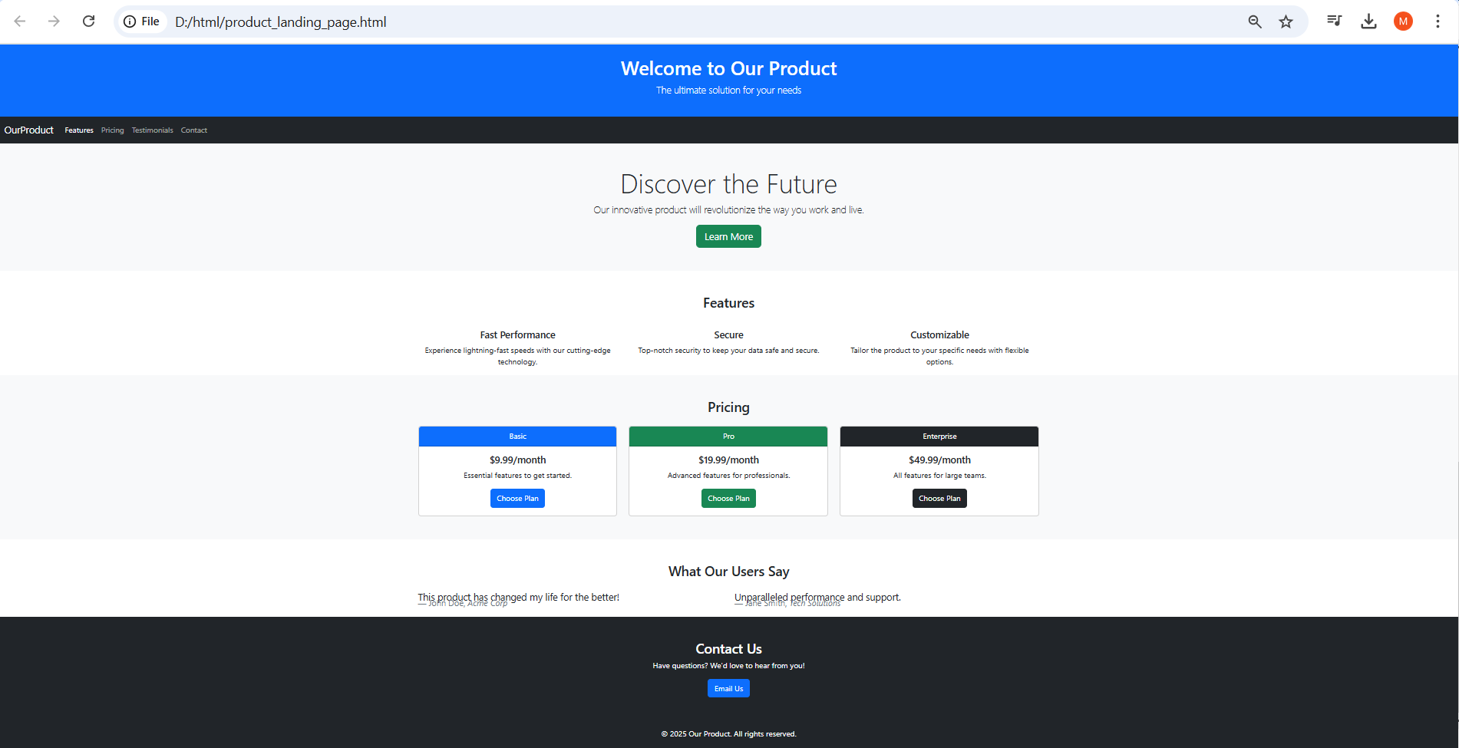

**Code:**

| <!DOCTYPE html>  <html lang="en">  <head>  <meta charset="UTF-8">  <meta name="viewport" content="width=device-width, initial-scale=1.0">  <title>Product Landing Page</title>  <link href="https://cdn.jsdelivr.net/npm/bootstrap@5.3.0/dist/css/bootstrap.min.css" rel="stylesheet">  </head>  <body>  <!-- Header Section -->  <header class="bg-primary text-white text-center">  <h1>Welcome to our Product</h1>  <p style="margin-bottom: 0%">The Ultimate solution for your needs</p>  </header>  <!-- Navigation Bar -->  <nav class="navbar navbar-expand-lg navbar-dark bg-dark">  <div class="container-fluid">  <a href="#" class="navbar-brand">Our Product</a>  <div class="collapse navbar-collapse">  <ul class="navbar-nav">  <li class="nav-item"><a href="" class="nav-link">Features</a></li>  <li class="nav-item"><a href="" class="nav-link">Pricing</a></li>  <li class="nav-item"><a href="" class="nav-link">Testimonials</a></li>  <li class="nav-item"><a href="" class="nav-link">Contact</a></li>  </ul>  </div>  </div>  </nav>  <!-- Hero Section -->  <section class="bg-light text-center p-5">  <h2 class="display-4">Discover the Future</h2>  <p class="lead">Our innovative product will revolutionize the ways we work and live</p>  <a href="#" class="btn btn-success">Learn More</a>  </section>  <!-- Feature Section -->  <section class="container mt-5">  <h3 class="text-center mb-4">Features</h3>  <div class="row">  <div class="col-md-4 text-center">  <h5 class="mt-3">Fast Performance</h5>  <p>Experience lighting fast speed with our cutting edge technology.</p>  </div>  <div class="col-md-4 text-center">  <h5 class="mt-3">Secure</h5>  <p>Top-Notch Security to keep your data safe and Secure.</p>  </div>  <div class="col-md-4 text-center">  <h5 class="mt-3">Customizable</h5>  <p>Tailor the product to your specific needs with flexible options.</p>  </div>  </div>  </section>  <!-- Pricing Section -->  <section class="bg-light py-5">  <div class="container">  <h3 class="text-center mb-4">Pricing</h3>  <div class="row">  <!-- Basic Plan -->  <div class="col-md-4">  <div class="card text-center">  <div class="card-header bg-primary text-white">Basic</div>  <div class="card-body">  <h5 class="card-title">$10.99/month</h5>  <p class="card-text">Essential Feature to get started</p>  <a href="#" class="btn btn-primary">Choose Plan</a>  </div>  </div>  </div>  <!-- Pro Plan -->  <div class="col-md-4">  <div class="card text-center">  <div class="card-header bg-success text-white">Standard</div>  <div class="card-body">  <h5 class="card-title">$19.99/month</h5>  <p class="card-text">Advanced Feature for Professionals</p>  <a href="#" class="btn btn-success">Choose Plan</a>  </div>  </div>  </div>  <!-- Enterprise Plan -->  <div class="col-md-4">  <div class="card text-center">  <div class="card-header bg-dark text-white">Pro</div>  <div class="card-body">  <h5 class="card-title">$49.99/month</h5>  <p class="card-text">All Features for large teams</p>  <a href="#" class="btn btn-dark">Choose Plan</a>  </div>  </div>  </div>  </div>  </div>  </section>  <!-- Testimonials Section -->  <section class="container mt-5">  <h3 class="text-center mb-4">What our users say</h3>  <div class="row">  <div class="col-md-6">  <blockquote class="blockquote">  <p>This product has changed my life for the better.</p>  <footer class="blockquote-footer">John Doe, Acme Corp</footer>  </blockquote>  </div>  <div class="col-md-6">  <blockquote class="blockquote">  <p>Unparalleled performance and support.</p>  <footer class="blockquote-footer">Jane Smith, Tech Solutions</footer>  </blockquote>  </div>  </div>  </section>  <!-- Contact Section -->  <section class="bg-light py-5">  <div class="container">  <h3 class="text-center mb-4">Contact Us</h3>  <p class="text-center">Drop your opinion!</p>  <div class="text-center">  <a href="#" class="btn btn-primary">Contact Us</a>  </div>  </div>  </section>  <!-- Footer -->  <footer class="bg-dark text-white text-center py-3">  <p>&copy; 2025 Our Product, All Rights Reserved</p>  </footer>  </body>  </html> |
| --- |

**Output:**

|  |
| --- |

**Project 2 - Student Dashboard**

**Learning Objective:**

To understand responsive design, Bootstrap grid system and Bootstrap components

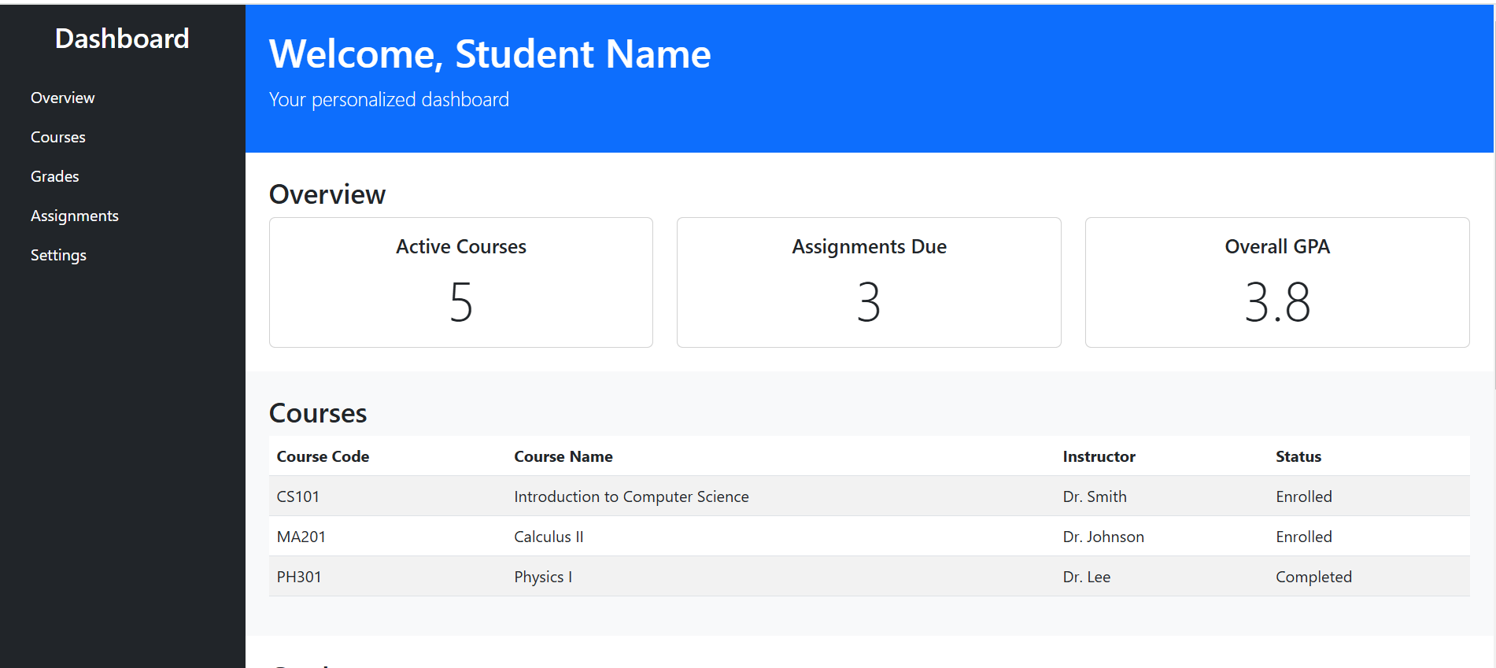

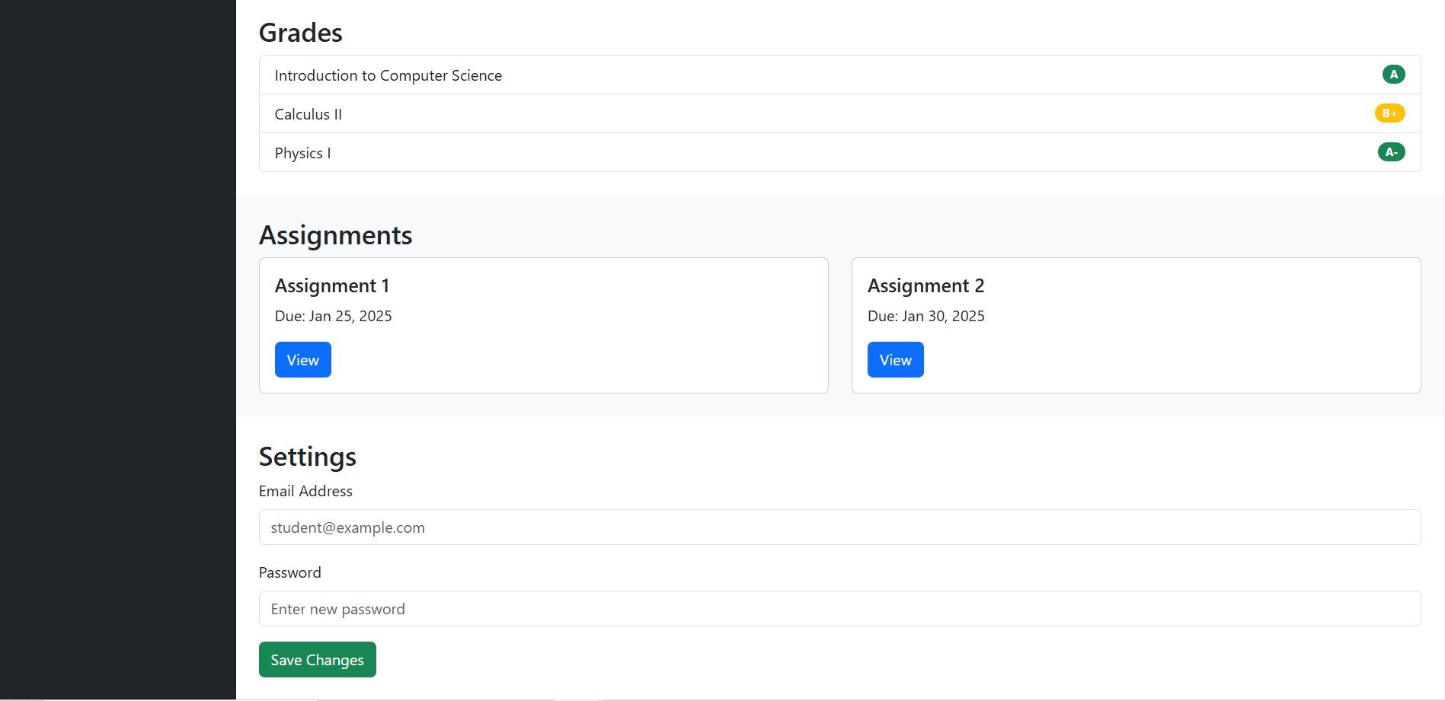

**Pre-requisites**

* Basic knowledge of HTML, CSS
* Understanding of Bootstrap framework
* Familiarity with responsive web design principles

**Resources Required**

* Bootstrap library (CSS and JS files)
* Text Editor like VSCode
* Web browser for testing

**Real-world Application of the Project**

Students use the dashboard to see their assigned projects, collaborate with students when teams have been chosen, submit check-ins and completed projects, and finally to manage their portfolio.

**The student dashboard consists of the following:**

Sidebar Navigation:

* Created using a <nav> element styled with Bootstrap classes like bg-dark, text-white, and p-3.
* Contains a vertical navigation menu with links to different sections of the dashboard.

1. Main Content Area:

* Uses flex-grow-1 to occupy the remaining space beside the sidebar.
* Divided into sections (Overview, Courses, Grades, Assignments, Settings).

1. Overview Section:

* Displays quick stats using the Bootstrap grid system (row and col-md-4).
* Cards (card class) show metrics like active courses, assignments due, and GPA.

1. Courses Section:

* A responsive table (table, table-striped) lists courses, instructors, and their status.

1. Grades Section:

* Uses Bootstrap’s list-group to display course grades with badges for highlighting performance.

1. Assignments Section:

* Shows upcoming assignments in cards with titles, due dates, and action buttons (btn-primary).

1. Settings Section:

* A simple form with form-control for input fields and btn-success for the save button.

**Code:**

| <html lang="en">  <head>  <link href="https://cdn.jsdelivr.net/npm/bootstrap@5.3.0/dist/css/bootstrap.min.css" rel="stylesheet">  </head>  <body>  <div class="d-flex"><!--using flexbox layout-->  <!-- NAVIGATION-->  <!--sidebar navigation-->  <nav class="bg-dark text-white p-3" style="width:250px; min-height:100vh">  <h3 class="text-center">DASHBOARD</h3>  <ul class="nav flex-column mt-4">  <li class="nav-item"><a href="" class="nav-link text-white">Overview</a></li>  <li class="nav-item"><a href="" class="nav-link text-white">Grades</a></li>  <li class="nav-item"><a href="" class="nav-link text-white">Courses</a></li>  <li class="nav-item"><a href="" class="nav-link text-white">Assignments</a></li>  <li class="nav-item"><a href="" class="nav-link text-white">Settings</a></li>    </ul>  </nav>  <!--Main Content-->  <div class="flex-grow-1">  <header class="bg-primary text-white p-4">  <h1>Welcome, Studdent Name</h1>  <p>Your personalied dahsboard</p>  <p></p>  </header>  <!--Overview-->  <section class="p-4">  <h3>Overview</h3>  <div class="row">  <div class="col-md-4"><!--Column-->  <div class="card"><!--Card-->  <div class="card-body text-center"><!--card body-->  <h5 class="card-title">Acive Courses</h5>  <p class="card-text display-4">5</p>  </div>  </div>  </div>  <div class="col-md-4"><!--Column-->  <div class="card"><!--Card-->  <div class="card-body text-center"><!--card body-->  <h5 class="card-title">Assignments due</h5>  <p class="card-text display-4">3</p>  </div>  </div>  </div>  <div class="col-md-4"><!--Column-->  <div class="card"><!--Card-->  <div class="card-body text-center"><!--card body-->  <h5 class="card-title">Overall CGPA</h5>  <p class="card-text display-4">9.8</p>  </div>  </div>  </div>  </div>  </section>  <!--Courses-->  <section class="bg-light p-4">  <h3>Courses</h3>  <table class="table table-stripped">  <thead>  <tr>  <th>Course Code</th>  <th>Course Name</th>  <th>Faculty</th>  <th>Status</th>  </tr>  </thead>  <tbody>  <tr>  <td>CS101</td>  <td>Introduction to ComputerScience</td>  <td>Dr. Smith</td>  <td>Entrolled</td>  </tr>  <tr>  <td>MA201</td>  <td>Calculus II</td>  <td>Dr. Johnson</td>  <td>Entrolled</td>  </tr>  <tr>  <td>BH103</td>  <td>Physics I</td>  <td>Dr. Lee</td>  <td>Completed</td>  </tr>  </tbody>  </table>  </section>  <section class="p-4"><!--Grades-->  <h3>Grades</h3>  <ul class="list-group">  <li class="list-group-item d-flex justify-content-between align-items-center">Introduction to Computer Science  <span class="badge bg-success rounded pill">A</span>  </li>  <li class="list-group-item d-flex justify-content-between align-items-center">Calculus II  <span class="badge bg-warning rounded pill">B+</span>  </li>  <li class="list-group-item d-flex justify-content-between align-items-center">Phyiscs I  <span class="badge bg-success rounded pill">A</span>  </li>  </ul>  </section>  <!--Assignment Section-->  <section class="p-4">  <h3>Assignments</h3>  <div class="row"><!--row-->  <div class="col-md-6"><!--column-->  <div class="card"><!--card-->  <div class="card-body"><!--Card body-->  <h5 class="card-title">Assignment 1</h5>  <p class="card-text">Due: March 04, 2025</p>  <a href="" class="btn btn-primary">View</a>  </div>  </div>  </div>  <div class="col-md-6"><!--column-->  <div class="card"><!--card-->  <div class="card-body"><!--Card body-->  <h5 class="card-title">Assignment 2</h5>  <p class="card-text">Due: March 20, 2025</p>  <a href="" class="btn btn-primary">View</a>  </div>  </div>  </div>  </div>  </section>  <!--Settings-->  <section class="p-4">  <h3>Settings</h3>  <form action="">  <div class="mb-3">  <label for="email" class="form-label">Email Address</label>  <input type="email" placeholder="student@something.com" class="form-control">  </div>  <div class="mb-3">  <label class="form-label" for="password">Enter Password</label>  <input class="form-control" type="password" placeholder="Enter New Password">  </div>  <button class="btn btn-success">Save Changes</button>  </form>  </section>  </div>  </div>  </body>  </html> |
| --- |

**Output:**

|  |
| --- |

**Project 3 - Responsive Personal Portfolio**

**Learning Objective:**

To understand responsive design, Bootstrap grid system and Bootstrap components

**Pre-requisites**

* Basic knowledge of HTML, CSS
* Understanding of Bootstrap framework
* Familiarity with responsive web design principles

**Resources Required**

* Bootstrap library (CSS and JS files)
* Text Editor like VSCode
* Web browser for testing

**Real-world Application of the Project**

* Personal portfolio websites are a perfect way to add a bit of personalization to a job application to help it stand out from the basics and the norm, making you a more memorable applicant..

**The responsive Personal Portfolio Page includes the following sections:**

* Hero Section: Introduces the portfolio with a call-to-action(CTA) button.
* About Section: Highlights your bio with an image
* Skills Section: Lists skills in a three-column layout
* Projects Section: Displays projects using Bootstrap cards
* Contact Section: Includes a contact form with placeholders

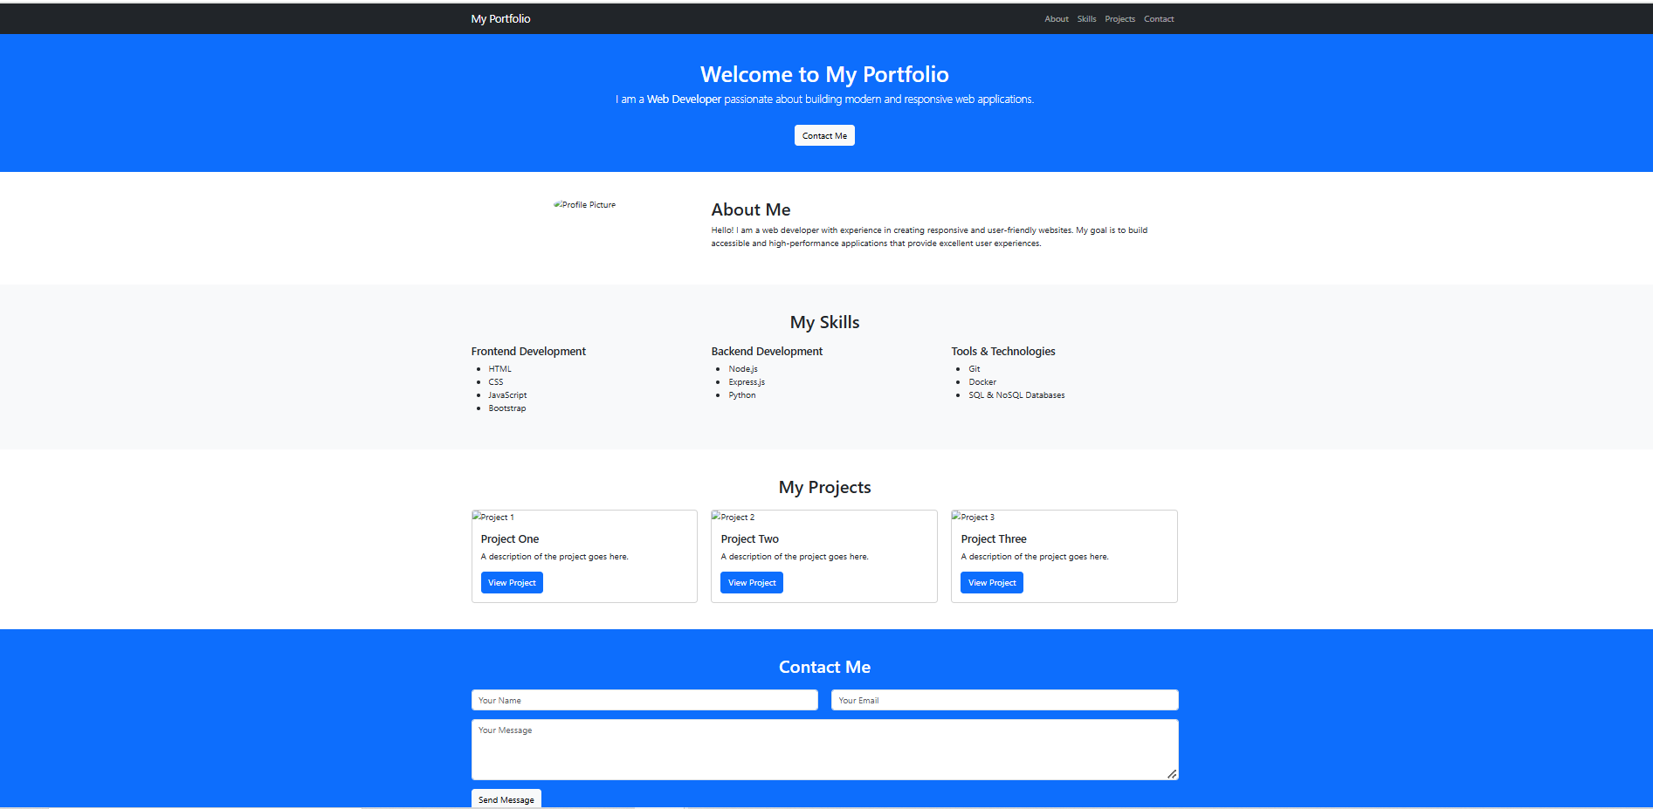

Code Implementation

1. Project Structure

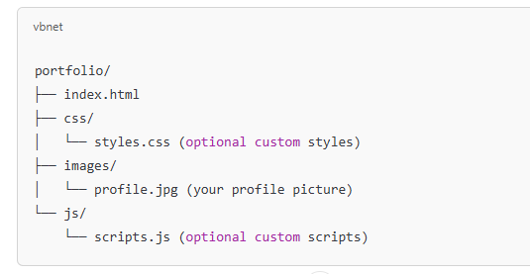

1. **Code: index.html**

| <!DOCTYPE html>  <html lang="en">  <head>  <meta charset="UTF-8">  <meta name="viewport" content="width=device-width, initial-scale=1.0">  <title>Personal Portfolio</title>  <link href="https://cdn.jsdelivr.net/npm/bootstrap@5.3.0/dist/css/bootstrap.min.css" rel="stylesheet">  </head>  <body>  <!--NAVBARD-->  <nav class="navbar navbar-expand-lg navbar-dark bg-dark">  <div class="container">  <a href="" class="navbar-brand">My Portfolio</a>  </div>  <div class="collapse navbar-collapse">  <ul class="navbar-nav mg-auto">  <li class="nav-item"><a class="nav-link" href="">About</a></li>  <li class="nav-item"><a class="nav-link" href="">Skills</a></li>  <li class="nav-item"><a class="nav-link" href="">Projects</a></li>  <li class="nav-item"><a class="nav-link" href="">Contact</a></li>  </ul>  </div>  </nav>  <!--About Section-->  <header class="bg-primary text-white text-center py-5">  <div>  <h1>Welcome to My Portfolio</h1>  <p>  I'm a <strong>web developer</strong> with a passion for creating innovative and user-friendly websites.  </p>  <a href="">Contact me</a>  </div>  </header>  <!--about-->  <section>  <div class="container"><!--container-->  <div class="row"><!--row-->  <div class="col-md-4"><!--column-->  <img class="img-fluid rounded-circle" src="C:\Users\Lenovo\Pictures\photos\IMG-20250211-WA0007copy.jpg" alt="">  </div>  <div class="col-md-8"><!--column-->  <h2>About Me</h2>  <p>Hello I am a web developer with experience in creating responsive user and user-friendly websites.  My goal is to build accessible and high performance applications that provide excellent user experience.  </p>  </div>  </div>  </div>  </section>  <!--Skill Section-->  <section class="bg-light py-5">  <div class="container"><!--Container-->  <h2 class="text-center mb-4">My Skills</h2>  <div div class="row"><!--row-->  <div class="col-md-4"><!--columns-->  <h4>Frontend Development</h4>  <ul>  <li>HTML</li>  <li>CSS</li>  <li>Javascript</li>  <li>Bootstrap</li>  </ul>  </div>  <div class="col"><!--column-->  <h4>Backend Development</h4>  <ul>  <li>Node.JS</li>  <li>Express Js</li>  <li>Python</li>  </ul>  </div>  <div class="col"><!--Column-->  <h4>Database</h4>  <ul>  <li>Git</li>  <li>Docker</li>  <li>SQL & NoSQL Databases</li>  </ul>  </div>  </div>  </div>  </section>  <!--Projects-->  <section class="py-5">  <div class="container"><!--Container-->  <div class="row"><!--row-->  <div class="col-md-4"><!--column-->  <div class="card text-center"><!--Card-->  <div><img src="C:\Users\Lenovo\Pictures\project.png" alt="" class="card-img-top" style="height:200px;"></div>  <div class="card-body"><!--Card Body-->  <h5 class="card-title">Project One</h5>  <p class="card-text">Description of Project</p>  <a href="" class="btn btn-primary">View Project</a>  </div>  </div>  </div>  <div class="col-md-4"><!--column-->  <div class="card text-center"><!--Card-->  <div><img class="card-img-top rounded-circle" src="C:\Users\Lenovo\Pictures\project.png" alt="" style="height:200px;"></div>  <div class="card-body"><!--Card Body-->  <h5 class="card-title">Project two</h5>  <p class="card-text">Description of Project</p>  <a href="" class="btn btn-primary">View Project</a>  </div>  </div>  </div>  <div class="col-md-4"><!--column-->  <div class="card"><!--Card-->  <div><img class="card-img-top rounded-circle" src="C:\Users\Lenovo\Pictures\project.png" alt="" style="height:200px;"></div>  <div class="card-body"><!--Card Body-->  <h5 class="card-title">Project Three</h5>  <p class="card-text">Description of Project</p>  <a href="" class="btn btn-primary">View Project</a>  </div>  </div>  </div>  </div>  </div>  </section>  <!--Contact Us-->  <section class="bg-primary text-white py-5">  <div class="container"><!--Container-->  <h2 class="text-center mb-4">Contact Me</h2>  </div>  <form action="">  <div class="row"><!--Row-->  <div class="col-md-6 mb-3"><!--Column-->  <input type="text" placeholder="Your Name" class="form-control">  </div>  <div class="col-md-6 mb-3"><!--col-->  <input type="email" placeholder="Your Email" class="form-control">  </div>  </div>  <div class="mb-3"><!--row-->  <textarea placeholder="Your Message" rows="4" class="form-control"></textarea>  </div>  <button type="submit" class="btn btn-success">Send Message</button>  </form>  </section>  <!--Footer-->  <footer class="bg-dark text-white text-center py-3">  <p>  &copy; 2025 My Portfolio. All Rights Reserved.  </p>  </footer>  </body>  </html> |
| --- |

**Output:**

|  |
| --- |

**Project 4 : e-Commerce Product Page**

**Learning Objective:**

To understand responsive design, Bootstrap grid system and Bootstrap components

**Pre-requisites**

* Basic knowledge of HTML, CSS
* Understanding of Bootstrap framework
* Familiarity with responsive web design principles

**Resources Required**

* Bootstrap library (CSS and JS files)
* Text Editor like VSCode
* Web browser for testing

**Real-world Application of the Project**

Real-world application of an e-commerce product page is the detailed online display of a product on a retail website like Amazon, where customers can view high-quality images, read descriptions, see different variations (like color or size), check availability, add items to their cart, and ultimately purchase the product directly from the page, all without physically going to a store.

The e-Commerce Product page contains the following sections:

1. Navigation Bar
2. Product Images
3. Product Details
4. Footer

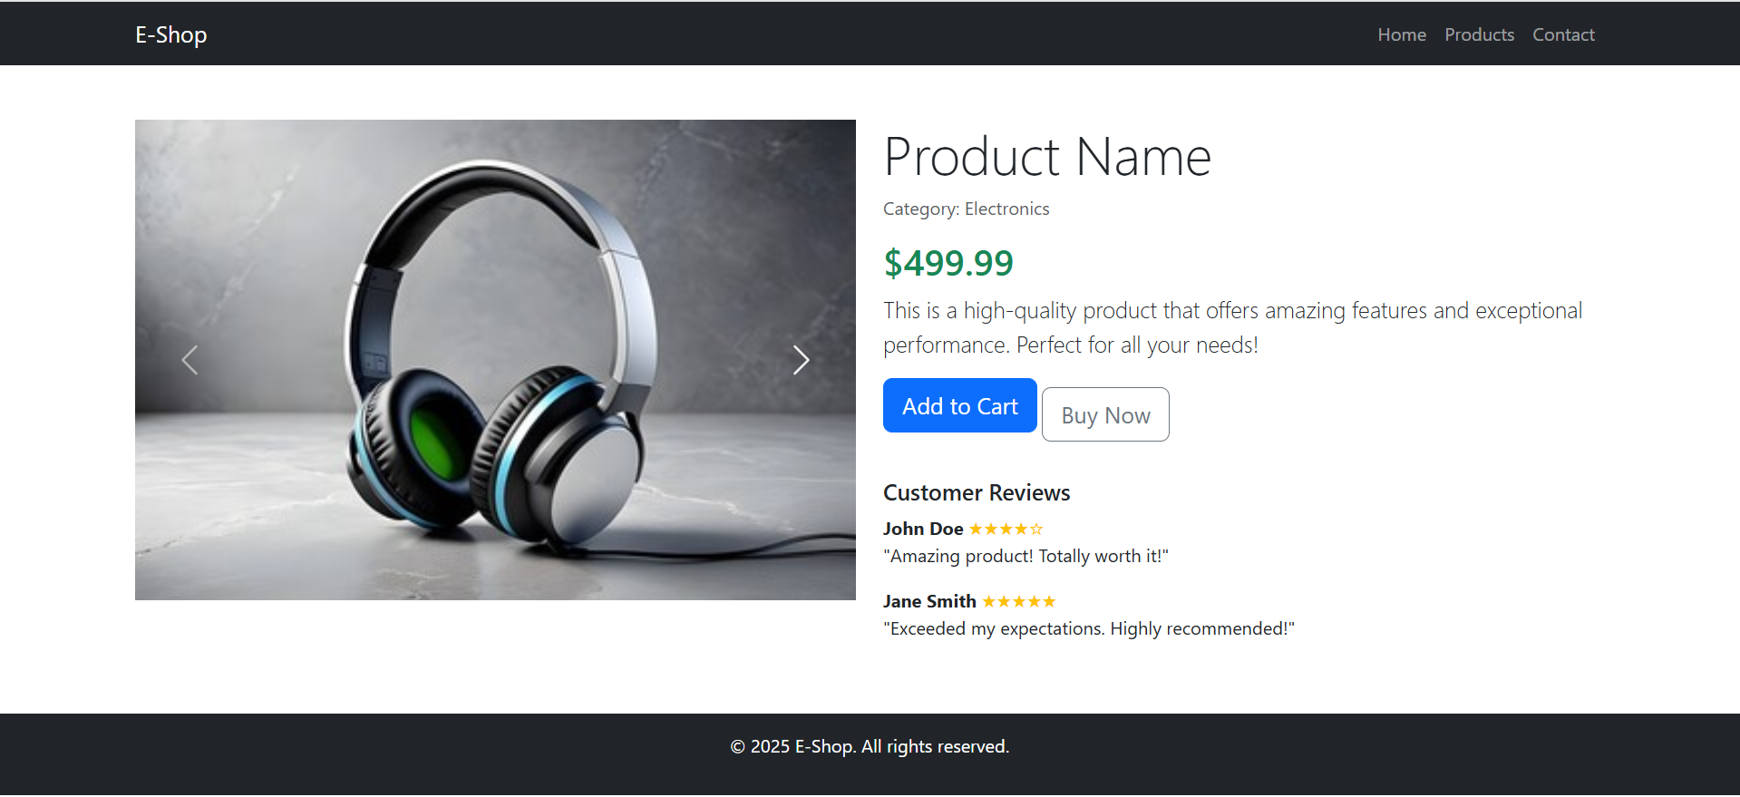

Code:

| <!DOCTYPE html>  <html lang="en">  <head>  <meta charset="UTF-8">  <meta name="viewport" content="width=device-width, initial-scale=1.0">  <title>E-Shop Product Page</title>  <link href="https://cdn.jsdelivr.net/npm/bootstrap@5.3.0/dist/css/bootstrap.min.css" rel="stylesheet">  <style>  body { background-color: #f8f9fa; }  a{text-decoration-color:light grey;}  .product-container { max-width: 1100px; margin: auto; padding: 20px; background: white; border-radius: 10px; box-shadow: 0 0 10px rgba(0,0,0,0.1); }  .price { color: green; font-size: 1.8rem; font-weight: bold; }  .footer { text-align: center; padding: 10px; background: #343a40; color: white; margin-top: 20px; }  .carousel img { max-height: 400px; object-fit: contain;}  </style>  </head>  <body>  <!--navigationbar-->  <nav class="navbar navbar-dark bg-dark">  <div class="container">  <a class="navbar-brand" href="#">E-Shop</a>  <div>  <a class="text-white me-3" href="#">Home</a>  <a class="text-white me-3" href="#">Products</a>  <a class="text-white " href="#">Contact</a>  </div>  </div>  </nav>  <!--product container in div-->>  <div class="container mt-4 product-container">  <div class="row">  <div class="col-md-6">  <div id="productCarousel" class="carousel slide" data-bs-ride="carousel">  <div class="carousel-inner">  <div class="carousel-item active">  <img src="E:\BootStrap\img\headphone1.webp" class="d-block w-100" alt="Product Image 1">  </div>  <div class="carousel-item">  <img src="E:\BootStrap\img\headphone2.jpg" class="d-block w-100" alt="Product Image 2">  </div>  <div class="carousel-item">  <img src="E:\BootStrap\img\headphone3.jpg" class="d-block w-100" alt="Product Image 3">  </div>  </div>  <button class="carousel-control-prev" type="button" data-bs-target="#productCarousel" data-bs-slide="prev">  <span class="carousel-control-prev-icon" aria-hidden="true"></span>  <span class="visually-hidden">Previous</span>  </button>  <button class="carousel-control-next" type="button" data-bs-target="#productCarousel" data-bs-slide="next">  <span class="carousel-control-next-icon" aria-hidden="true"></span>  <span class="visually-hidden">Next</span>  </button>  </div>  </div>  <div class="col-md-6">  <!--Name of the product-->>  <h2>JBL Tune 510BT</h2>  <p class="text-muted">Category: Electronics</p>  <!--cost of the product-->>  <p class="price">$499.99</p>  <p>JBL Pure Bass Sound</p>  <!--Description of the product-->  <p>The JBL Tune 510BT headphones let you stream powerful JBL Pure Bass sound with no strings attached. Easy to use, these headphones provide up to 40 hours of pure pleasure and an extra 2 hours of battery with just 5 minutes of power with the USB-C charging cable.</p>  <!--button-->  <button class="btn btn-primary">Add to Cart</button>  <button class="btn btn-secondary">Buy Now</button>  <hr>  <h5>Customer Reviews</h5>  <p><strong>John Doe</strong> <span class="text-warning">★★★★★</span><br>"Amazing product! Totally worth it!"</p>  <p><strong>Jane Smith</strong> <span class="text-warning">★★★★★</span><br>"Exceeded my expectations. Highly recommended!"</p>  </div>  </div>  </div>    <div class="footer">  &copy; 2025 E-Shop. All rights reserved.  </div>  <script src="https://cdn.jsdelivr.net/npm/bootstrap@5.3.0/dist/js/bootstrap.bundle.min.js"></script>  </body>  </html> |
| --- |

Output:

|  |
| --- |

**Project 5:** **DIGITAL CALCULATOR**

Create a digital calculator using HTML, CSS and jQuery

**Features of the Calculator**

* Basic arithmetic operations: Addition, Subtraction, Multiplication, Division
* Advanced functions: Square Root (√) and Pi (π)
* Clear (C) and Backspace (←) functions
* Styled with CSS to look like a real calculator
* jQuery handles interactive events

**Step 1: Project Setup**

Create the following files in a folder:

* index.html (for the structure)
* style.css (for styling)
* script.js (for the functionality)

**Step 2: Create the Calculator UI with HTML**

Create an HTML file (index.html) and set up the calculator layout.

| <!DOCTYPE html>  <html lang="en">  <head>  <meta charset="UTF-8">  <meta name="viewport" content="width=device-width, initial-scale=1.0">  <title>Digital Calculator</title>  <link rel="stylesheet" href="style.css">  <script src="https://code.jquery.com/jquery-3.6.0.min.js"></script>  <script src="https://cdnjs.cloudflare.com/ajax/libs/jquery-validate/1.19.5/jquery.validate.min.js"></script>  <script src="script.js"></script>  </head>  <body>  <div class="calculator">  <input type="text" id="display" readonly>  <div class="buttons">  <button class="operator" id="clear">C</button>  <button class="operator" id="backspace">B</button>  <button class="operator" id="sqrt">Sqrt</button>  <button class="operator" id="pi">pi</button>  <button class="number">7</button>  <button class="number">8</button>  <button class="number">9</button>  <button class="operator">/</button>  <button class="number">4</button>  <button class="number">5</button>  <button class="number">6</button>  <button class="operator">*</button>  <button class="number">1</button>  <button class="number">2</button>  <button class="number">3</button>  <button class="operator">-</button>  <button class="number">0</button>  <button class="operator">.</button>  <button id="equals">=</button>  <button class="operator">+</button>  </div>  </div>  </body>  </html> |
| --- |

**Step 3: Style the Calculator with CSS**

Create style.css to design the calculator.

| body {  background-color: whitesmoke;  font-family: Arial,Helvetica,sans-serif;  display: flex;  justify-content: center;  align-items: center;  height: 100vh;  }  .calculator{  width: 50%;  height: 350px;  background-color: #333;  padding: 10px;  border: none;  text-align: center;  color: white;  border-radius: 5px;  }  .buttons{  display: grid;  grid-template-columns: repeat(4,1fr);  gap: 10px;  margin-top: 10px;  }  button{  width: 100%;  height: 50px;  font-weight: bold;  border: none;  border-radius: 5px;  cursor: pointer;  }  .number{  background-color: #444;  color: white;  }  .operator{  background-color: orange;  color: white;  }  #equals{  background-color: #28a745;  color: white;  }  #clear{  background-color: #dc3545;  color: white;  }  #backspace{  background-color: #007bff;  color: white;  }  button:hover{  opacity: 0.8;  }  #display{  width: 100%;  height: 50px;  text-align: right;  background-color: #333;  color: white;  border: 2px solid white;  margin-right: 8px;  border-radius: 5px;  } |
| --- |

**Step 4: Implement the Functionality with jQuery**

Create script.js to handle button clicks and calculations.

| $(document).ready(function() {  let display=$("#display");  $(".number,.operator").click(function() {  let value=$(this).text();  display.val(display.val()+value)  });  $("#equals").click(function(){  try{  display.val(eval(display.val()))  }catch(error){  display.val("Error")  }  });  $("#clear").click(function(){  display.val("");  });  $("#backspace").click(function(){  let currentValue=display.val();  len=currentValue.length;  display.val(currentValue.slice(0,len-2))  });  $("#sqrt").click(function(){  let currentValue=parseFloat(display.val());  display.val(Math.sqrt(currentValue));    });  $("#pi").click(function(){  let v=Math.PI.toFixed(5);  display.val(v);  });  }); |
| --- |

**Output:**

|  |
| --- |

**Project 6 :** **RESPONSIVE MENU**

Create a responsive, customizable menu using HTML, CSS and jQuery. The menu supports the different styles (horizontal, vertical, accordion), accepts click and hover inputs, and integrates Font Awesome icons for a sleek look.

**Project Overview**

**Features**

● **Three menu styles:** Horizontal, Vertical, Accordion

● **Interactivity:** Click or hover to expand/collapse menu items

● **Customizable with Font Awesome Icons**

● **Responsive Design**

**Step 1: Project Setup**

Create three files:

● index.html → Structure (HTML)

● style.css → Styling (CSS)

● script.js → Interactive behavior (jQuery)

**Step 2: Writing the HTML Structure**

Create a basic navigation menu in index.html:

| <!DOCTYPE html>  <html lang="en">  <head>  <meta charset="UTF-8">  <meta name="viewport" content="width=device-width, initial-scale=1.0">  <title>Responsive Menu</title>  <link rel="stylesheet" href="menu.css">  <link rel="stylesheet" href="https://cdnjs.cloudflare.com/ajax/libs/font-awesome/6.0.0/css/all.min.css">  </head>  <body>  <nav class="menu">  <ul class="menu-list">  <li><a href="#"><i class="fa fa-home"></i> Home</a></li>  <li>  <a href="#"><i class="fa fa-cog"></i> Settings</a>  <ul class="submenu">  <li><a href="#">Profile</a></li>  <li><a href="#">Account</a></li>  <li><a href="#">Security</a></li>  </ul>  </li>  <li>  <a href="#"><i class="fa fa-info-circle"></i> About</a>  <ul class="submenu">  <li><a href="#">Company</a></li>  <li><a href="#">Team</a></li>  </ul>  </li>  <li><a href="#"><i class="fa fa-envelope"></i> Contact</a></li>  </ul>  </nav>  <script src="https://code.jquery.com/jquery-3.6.0.min.js"></script>  <script src="menu.js"></script>  </body>  </html |
| --- |

**Step 3: Styling in CSS**

| body {  font-family: Arial, sans-serif;  margin: 0;  padding: 0;  }  nav.menu {  background-color: #333;  padding: 10px 20px;  width: 100%;  }  .menu-list {  list-style: none;  display: flex;  justify-content: space-around;  margin: 0;  padding: 0;  }  .menu-list li {  position: relative;  margin-right: 20px;  }  .menu-list li a {  text-decoration: none;  color: white;  padding: 10px 15px;  display: block;  }  .menu-list li a:hover {  background-color: #575757;  }  .submenu {  display: none;  position: absolute;  background-color: #444;  list-style: none;  margin: 0;  padding: 0;  top: 100%;  left: 0;  }  .menu-list li:hover .submenu {  display: block;  }  @media (max-width: 768px) {  .menu-list {  flex-direction: column;  }  } |
| --- |

**Step 4: Adding Interactivity with jQuery**

Write the interactive logic in script.js.

| $(document).ready(function () {  $('.menu-list li').hover(function () {  $(this).find('.submenu').stop(true, true).slideDown();  }, function () {  $(this).find('.submenu').stop(true, true).slideUp();  });  }); |
| --- |

**Output:**

|  |
| --- |

**Project 7 : jQuery FAQs Accordion**

A jQuery FAQ accordion is a common UI component used to display FAQs in a collapsible format, where clicking a question expands the answer while collapsing other open answers. This improves readability and user experience.

**Step 1: Project Setup**

Create three files:

● index.html → Structure (HTML)

● style.css → Styling (CSS)

● script.js → Interactive behavior (jQuery)

**Step 2: Writing the HTML Structure**

Create a basic navigation menu in index.html:

| <!DOCTYPE html>  <html lang="en">  <head>  <meta charset="UTF-8">  <meta name="viewport" content="width=device-width, initial-scale=1.0">  <title>Frequently Asked Questions (FAQs)</title>  <link rel="stylesheet" href="faq_4.css">  <script src="https://code.jquery.com/jquery-3.6.0.min.js"></script>  <script src="faq_4.js"></script>  </head>  <body>  <div class="faq-container">  <h2>Frequently Asked Questions</h2>    <div class="faq-item">  <div class="faq-question">  What is jQuery?  <span class="icon">+</span>  </div>  <div class="faq-answer">  jQuery is a fast, small, and feature-rich JavaScript library. It simplifies HTML document traversal, event handling, and animations.  </div>  </div>  <div class="faq-item">  <div class="faq-question">  How does the FAQ accordion work?  <span class="icon">+</span>  </div>  <div class="faq-answer">  Clicking a question expands the answer, while the other answers remain collapsed.  </div>  </div>  <div class="faq-item">  <div class="faq-question">  Can I customize this accordion?  <span class="icon">+</span>  </div>  <div class="faq-answer">  Yes! You can change colors, animations, and even use different styles.  </div>  </div>  </div>  </body>  </html> |
| --- |

**Step 3: Styling in CSS**

| body{  font-family: Arial, Helvetica, sans-serif;  background-color: #f4f4f4;  margin:0;  padding: 20px;  }  .faq-container{  max-width: 600px;  margin: auto;  background: white;  padding: 20px;  border-radius: 5px;  }  .faq-item{  border-bottom: 1px solid #ddd;  margin-bottom: 10px;  }  .faq-question{  background: #007bff ;  padding: 10px;  cursor: pointer;  font-size: 18px;  display: flex;  justify-content: space-between;  align-items: center;  }  .faq-answer{  padding: 10px;  background-color: #f9f9f9;  border-left: 4px solid #007bff;  display: none;  }  .icon{  font-weight: bold;  } |
| --- |

**Step 4: Adding Interactivity with jQuery**

Write the interactive logic in script.js.

| $(document).ready(function () {  $('.faq-question').on('click', function () {  $('.faq-answer').not($(this).next()).slideUp();  $('.icon').not($(this).find('.icon')).text('+');  $(this).next('.faq-answer').slideToggle();  const icon = $(this).find('.icon');  icon.text(icon.text() === '+' ? '-' : '+');  });  }); |
| --- |

**Output:**

|  |
| --- |

**Project 8 : jQuery Tabs**

jQuery tabs allow users to switch between different content sections without reloading the page. This is useful for organizing content efficiently.

**Step 1: Project Setup**

Create three files:

● index.html → Structure (HTML)

● style.css → Styling (CSS)

● script.js → Interactive behavior (jQuery)

**Step 2: Writing the HTML Structure**

Create a basic navigation menu in index.html:

| <!DOCTYPE html>  <html lang="en">  <head>  <meta charset="UTF-8">  <meta name="viewport" content="width=device-width, initial-scale=1.0">  <link rel="stylesheet" href="https://cdnjs.cloudflare.com/ajax/libs/font-awesome/6.0.0/css/all.min.css">  <link rel="stylesheet" href="tab1.css">  <script src="https://code.jquery.com/jquery-3.6.0.min.js"></script>  <script src="tab1.js"></script>  <title>Document</title>  </head>  <body>  <div class="tabs">  <div class="tab active" data-tab="tab1">Tab1</div>    <div class="tab" data-tab="tab2">Tab2</div>  <div class="tab" data-tab="tab3">Tab3</div>  </div>  <div class="tab-contents">  <div id="tab1" class="tab-content active">  <h2>Content for Tab1 </h2>  <p>This is a content for Tab1 </p>  </div>  <div id="tab2" class="tab-content">  <h2>Content for Tab2</h2>  <p>This is a content for Tab2</p>  </div>  <div id="tab3" class="tab-content">  <h2>Content for Tab3</h2>  <p>This is a content for Tab3</p>  </div>  </div>  </body>  </html> |
| --- |

**Step 3: Styling in CSS**

| body{  font-family: Arial, Helvetica, sans-serif;  margin: 50px;  }  .tabs{  display: flex;  border-bottom: 2px solid blue;  }  .tab{  padding: 10px 20px;  cursor: pointer;  border: 1px solid blue;  border-bottom: none;  background-color:aliceblue;  border-radius: 5px;  }  .tab.active{  background: blue;  color: white;  }  .tab-content{  padding: 20px;  border: 1px solid blue;  border-radius: 0 0 5px 5px;  display: none;  }  .tab-content.active{  display: block;  } |
| --- |

**Step 4: Adding Interactivity with jQuery**

Write the interactive logic in script.js.

| $(document).ready(function(){  $(".tab").click(function(){  $(".tab").removeClass('active');  $(this).addClass('active');  $('.tab-content').removeClass('active');  $('#'+$(this).data('tab')).addClass('active');  });  }); |
| --- |

**Output:**

|  |
| --- |

**Practical 9 : jQuery Selectable - Interactive Item Selection**

The **jQuery UI Selectable** feature allows users to select multiple items using mouse clicks or drag selection. This is useful for interactive lists, file selection, or multi-item selection interfaces.

**Step 1: Project Setup**

Create three files:

● index.html → Structure (HTML)

● style.css → Styling (CSS)

● script.js → Interactive behavior (jQuery)

**Step 2: Writing the HTML Structure**

Create a basic navigation menu in index.html:

| <!DOCTYPE html>  <html lang="en">  <head>  <meta charset="UTF-8">  <meta name="viewport" content="width=device-width, initial-scale=1.0">  <title>jQuery UI Selectable</title>  <link rel="stylesheet" href="https://code.jquery.com/ui/1.13.2/themes/base/jquery-ui.css">  <link rel="stylesheet" href="my_selectable.css">  <script src="https://code.jquery.com/jquery-3.6.0.min.js"></script>    <script src="https://code.jquery.com/ui/1.13.2/jquery-ui.js"></script>  <script src="my_selectable.js"></script>  </head>  <body>  <div class="selectable-container">  <h2>Select Items</h2>  <ul id="selectable" class="selectable-list">  <li>Item 1</li>  <li>Item 2</li>  <li>Item 3</li>  <li>Item 4</li>  <li>Item 5</li>  </ul>  <p id="selected-items"><strong>Selected Items: </strong><span></span></p>  </div>  </body>  </html> |
| --- |

**Step 3: Styling in CSS**

| body{  font-family: Arial, Helvetica, sans-serif;  }  .selectable-container{  width: 50%;  margin: auto;  }  .selectable-list{  list-style: none;  padding: 0;  margin: 0;  border: 1px solid #ccc;  border-radius: 5px;  padding: 10px;  }  .selectable-list li{  padding: 10px;  margin: 5px 0;  background-color: #f8f8f8;  cursor: pointer;  border: 1px solid #ddd;  border-radius: 3px;  }  .selectable-list .ui-selected {  background: #007bff !important;  color: white;  } |
| --- |

**Step 4: Adding Interactivity with jQuery**

Write the interactive logic in script.js.

| $(document).ready(function() {  $('#selectable').selectable({  stop: function() {  var selectedItems = [];  $('.ui-selected', this).each(function() {  selectedItems.push($(this).text());  });  $('#selected-items span').text(selectedItems.join(', '));  }  });  }); |
| --- |

**Output:**

|  |
| --- |

**Project 10 : Airline Reservation System**

The Airline Reservation System is a full-stack web project that allows users to:

● Search for available flights.

● Book tickets online.

● Manage reservations.

● Make secure payments.

**Project Requirements**

**1. Technologies Used**

● **Front-end:** HTML, Bootstrap, jQuery

● **Back-end:** PHP (or Node.js)

● **Database:** MySQL

● **Payment Gateway:** PayPal or Stripe

**Project Features**

**User Functionalities**

● Search flights by **destination, date, and airline**.

● Select seats from an **interactive seat map**.

● Manage reservations (**view, update, or cancel bookings**).

● Make **secure online payments**.

**Admin Functionalities (optional for now)**

● Add, update, or remove flights.

● Manage reservations and payments.

● Generate reports on flight bookings.

**Project Structure**

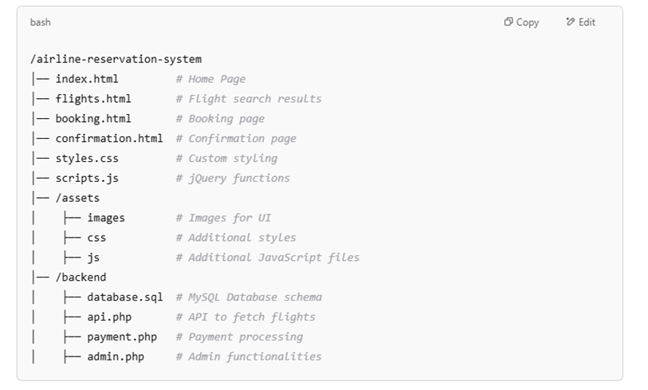

**Code:**

**Booking.html**

| <!DOCTYPE html>  <html lang="en">  <head>  <meta charset="UTF-8">  <meta name="viewport" content="width=device-width, initial-scale=1.0">  <title>Booking - SkyEase Airlines</title>  <link href="https://cdn.jsdelivr.net/npm/bootstrap@5.3.0/dist/css/bootstrap.min.css" rel="stylesheet">  </head>  <body>  <div class="container mt-5">  <h2 class="mb-4 text-center">Confirm Your Flight</h2>  <div class="card mb-4" id="flightInfo">  <img id="flightImage" class="card-img-top" alt="Flight Image">  <div class="card-body">  <h5 class="card-title" id="airlineName"></h5>  <p class="card-text" id="flightDetails"></p>  </div>  </div>  <h4>Enter Your Details</h4>  <form id="bookingForm">  <input type="hidden" id="id" name="id">  <div class="mb-3">  <label for="fullName" class="form-label">Full Name</label>  <input type="text" class="form-control" id="fullName" name="name" required>  </div>  <div class="mb-3">  <label for="email" class="form-label">Email</label>  <input type="email" class="form-control" id="email" name="email" required>  </div>  <div class="mb-3">  <label for="contact" class="form-label">Contact Number</label>  <input type="text" class="form-control" id="contact" name="contact" required>  </div>  <div class="mb-3">  <label for="seat" class="form-label">Seat Number</label>  <input type="text" class="form-control" id="seat" name="seat_number" required>  </div>  <div class="mb-3">  <label for="passengers" class="form-label">Number of Passengers</label>  <input type="number" class="form-control" id="passengers" name="passengers" required min="1" max="10">  </div>  <button type="submit" class="btn btn-success">Confirm Booking</button>  </form>  <footer class="mt-5 text-center text-muted">  <hr>  &copy; 2025 SkyEase Airlines. All rights reserved.  </footer>  </div>  <script>  const flight = JSON.parse(localStorage.getItem("selectedFlight"));  if (flight) {  document.getElementById("airlineName").textContent = flight.airline;  document.getElementById("flightDetails").innerHTML = `From: ${flight.from} <br> To: ${flight.to} <br> Departure: ${flight.time}`;  document.getElementById("flightImage").src = flight.image;  document.getElementById("id").value = flight.id;  }  document.getElementById("bookingForm").addEventListener("submit", function(e) {  e.preventDefault();  const formData = new URLSearchParams(new FormData(this));  fetch('submit.php', {  method: 'POST',  body: formData  })  .then(response => response.text())  .then(data => {  alert("Booking Confirmed!\nCheck your email for confirmation.");  window.location.href = "confirmation.html";  })  .catch(error => {  console.error('Error:', error);  alert('An error occurred. Please try again.');  });  });  </script>  </body>  </html> |
| --- |

**Index.html**

| **Code:**  <!DOCTYPE html>  <html lang="en">  <head>  <meta charset="UTF-8" />  <meta name="viewport" content="width=device-width, initial-scale=1.0" />  <title>Airline Reservation - Home</title>  <link href="https://cdn.jsdelivr.net/npm/bootstrap@5.3.0/dist/css/bootstrap.min.css" rel="stylesheet" />  <link rel="stylesheet" href="css/style.css">  </head>  <body>  <div class="container mt-5">  <h1 class="text-center mb-3">Welcome to SkyEase Airlines</h1>  <p class="text-center mb-5">Book your next adventure with us — fast, safe, and smooth!</p>  <div class="text-center mb-4">  <a href="flight.html" class="btn btn-primary btn-lg">Start Booking</a>  </div>  <h3 class="mb-4 text-center">Find Flights</h3>  <form id="searchForm">  <div class="mb-3">  <label for="fromDestination" class="form-label">From</label>  <select class="form-select" id="fromDestination" required>  <option value="">Select Source Location</option>  <option value="Mumbai">Mumbai</option>  <option value="Bangalore">Bangalore</option>  <option value="Chennai">Chennai</option>  <option value="Hyderabad">Hyderabad</option>  </select>  </div>  <div class="mb-3">  <label for="toDestination" class="form-label">To</label>  <select class="form-select" id="toDestination" required>  <option value="">Select Destination Location</option>  </select>  </div>  <div class="text-center">  <button type="submit" class="btn btn-primary btn-lg">Search Flights</button>  </div>  </form>  </div>  <script>  // Define the available flight routes for each source location  const flightRoutes = {  "Mumbai": ["Delhi", "Goa", "Kolkata"],  "Bangalore": ["Delhi", "Pune", "Goa"],  "Chennai": ["Delhi", "Goa", "Kolkata"],  "Hyderabad": ["Pune", "Kolkata"]  };  const fromDestination = document.getElementById("fromDestination");  const toDestination = document.getElementById("toDestination");  // Function to update the 'To' dropdown based on the selected 'From' location  function updateToDestinationOptions() {  const selectedFrom = fromDestination.value;    // Clear current 'To' options  toDestination.innerHTML = "<option value=''>Select Destination Location</option>";    // If a valid 'From' location is selected, populate 'To' destinations  if (selectedFrom) {  const availableDestinations = flightRoutes[selectedFrom] || [];  availableDestinations.forEach(function (destination) {  const option = document.createElement("option");  option.value = destination;  option.textContent = destination;  toDestination.appendChild(option);  });  }  }  // Event listener to update 'To' dropdown when 'From' location changes  fromDestination.addEventListener("change", updateToDestinationOptions);  // Form submission handling  document.getElementById("searchForm").addEventListener("submit", function (e) {  e.preventDefault();  const fromDestinationValue = fromDestination.value.trim();  const toDestinationValue = toDestination.value.trim();  if (fromDestinationValue && toDestinationValue) {  // Store the source and destination in localStorage  const searchDetails = { from: fromDestinationValue, to: toDestinationValue };  localStorage.setItem("searchDetails", JSON.stringify(searchDetails));  // Redirect to flight.html  window.location.href = "flight.html";  } else {  alert("Please select both source and destination locations.");  }  });  </script>  </body>  </html> |
| --- |

**Flight.html**

| **Code:**  <!DOCTYPE html>  <html lang="en">  <head>  <meta charset="UTF-8" />  <meta name="viewport" content="width=device-width, initial-scale=1.0" />  <title>Browse Flights</title>  <link href="https://cdn.jsdelivr.net/npm/bootstrap@5.3.0/dist/css/bootstrap.min.css" rel="stylesheet" />  <link rel="stylesheet" href="css/style.css" />  <style>  body {  background: linear-gradient(to right, #8e2de2, #4a00e0);  /* Purple gradient background */  font-family: 'Arial', sans-serif;  margin: 0;  display: flex;  align-items: center;  justify-content: center;  min-height: 100vh;  color: white;  /* Default text color */  }  .container {  background-color: rgba(255, 255, 255, 0.2);  /* Slightly transparent white container */  padding: 2rem;  border-radius: 1rem;  box-shadow: 0 0.5rem 1rem rgba(0, 0, 0, 0.2);  width: 90%;  max-width: 800px;  }  h2 {  color: white;  text-align: center;  margin-bottom: 2rem;  text-shadow: 0.05rem 0.05rem 0.1rem rgba(0, 0, 0, 0.3);  }  .flight-table {  width: 100%;  border-collapse: collapse;  margin-top: 20px;  background-color: rgba(255, 255, 255, 0.8);  /* Slightly transparent table */  color: #333;  }  .flight-table th,  .flight-table td {  border: 1px solid #ddd;  padding: 12px;  text-align: left;  }  .flight-table th {  background-color: rgba(242, 242, 242, 0.5);  /* Lighter shade for header */  font-weight: bold;  }  .flight-table img {  max-height: 80px;  }  #searchCriteria,  #flightSearch {  padding: 0.5rem;  margin-right: 0.5rem;  border-radius: 0.5rem;  border: 1px solid #ccc;  background-color: rgba(255, 255, 255, 0.7);  color: #333;  }  #searchCriteria:focus,  #flightSearch:focus {  outline: none;  border-color: #ff6b6b;  box-shadow: 0 0 0 0.2rem rgba(255, 107, 107, 0.25);  }  .book-btn {  background-color: #ff6b6b;  border-color: #ff6b6b;  color: white;  transition: background-color 0.3s ease;  }  .book-btn:hover {  background-color: #ff4757;  border-color: #ff4757;  }  #flightList p {  text-align: center;  color: white;  font-size: 1.2rem;  }  </style>  </head>  <body>  <div class="container mt-5">  <h2 class="mb-4">Browse Available Flights</h2>  <div class="mb-4 text-center">  <select id="searchCriteria">  <option value="airline">Airline</option>  <option value="time">Time</option>  <option value="to">Destination</option>  <option value="from">Starting Place</option>  </select>  <input type="text" id="flightSearch" placeholder="Search flights...">  </div>  <table class="flight-table" id="flightList">  <thead>  <tr>  <th>Airline</th>  <th>From</th>  <th>To</th>  <th>Departure Time</th>  <th>Actions</th>  </tr>  </thead>  <tbody>  </tbody>  </table>  </div>  <script>  const searchInput = document.getElementById('flightSearch');  const searchCriteria = document.getElementById('searchCriteria');  function displayFlights(flights) {  const tableBody = document.querySelector("#flightList tbody");  tableBody.innerHTML = ""; // Clear existing rows  if (flights.length === 0) {  tableBody.innerHTML = "<tr><td colspan='5'>No flights available.</td></tr>";  return;  }  const searchTerm = searchInput.value.toLowerCase();  const filterCriteria = searchCriteria.value;  const filteredFlights = flights.filter(flight => {  return flight[filterCriteria].toLowerCase().includes(searchTerm);  });  if (filteredFlights.length === 0) {  tableBody.innerHTML = "<tr><td colspan='5'>No flights match your search.</td></tr>";  return;  }  filteredFlights.forEach(flight => {  const row = document.createElement("tr");  row.innerHTML = `  <td>${flight.airline}</td>  <td>${flight.from}</td>  <td>${flight.to}</td>  <td>${flight.time}</td>  <td><button class="btn btn-success book-btn" data-id="${flight.id}" data-airline="${flight.airline}" data-from="${flight.from}" data-to="${flight.to}" data-time="${flight.time}" data-image="${flight.image}">Book Now</button></td>  `;  tableBody.appendChild(row);  });  }  // Fetch flight data from api.php  fetch("http://localhost/airline-reservation/api.php")  .then(response => response.json())  .then(flights => {  displayFlights(flights);  })  .catch(error => {  console.error("Error fetching flights:", error);  document.getElementById("flightList").innerHTML = "<p>Failed to load flights. Please try again later.</p>";  });  // Event listener for the search input  searchInput.addEventListener('input', () => {  fetch("http://localhost/airline-reservation/api.php")  .then(response => response.json())  .then(flights => {  displayFlights(flights);  })  .catch(error => {  console.error("Error fetching flights:", error);  document.getElementById("flightList").innerHTML = "<p>Failed to load flights. Please try again later.</p>";  });  });  // Handle Book Now click  document.addEventListener("click", function(e) {  if (e.target.classList.contains("book-btn")) {  const flightId = e.target.getAttribute("data-id");  const airline = e.target.getAttribute("data-airline");  const from = e.target.getAttribute("data-from");  const to = e.target.getAttribute("data-to");  const time = e.target.getAttribute("data-time");  const image = e.target.getAttribute("data-image");  const bookingUrl = `booking.html?id=${flightId}&airline=${airline}&from=${from}&to=${to}&time=${time}&image=${image}`;  window.location.href = bookingUrl;  }  });  </script>  </body>  </html> |
| --- |

**Output:**

|  |
| --- |